

[**www.dynamicsphysicaltherapy.com**](http://www.dynamicsphysicaltherapy.com)

**NAME** _     _ **AGE** _     _ **DATE** _     _

**BRIEF DESCRIPTION OF CURRENT PROBLEM**:

**HOW LONG HAVE YOU HAD PROBLEM**:       Days       Weeks       Months       Years

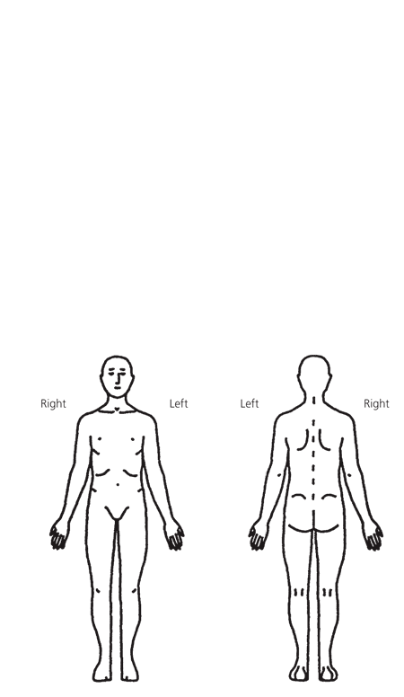

**HAVE YOU HAD SURGERY?** Date

**___________________________________________________________________________________________________**

**This next section will need to be completed by hand at the time of your visit:**

**1) Using the number rating system below, describe your:**

**Pain level *NOW*:**

Pain level at **BEST**:

Pain level at **WORST**:

(0-10)

(0-10)

(0-10)

In the past ***30 days***:

In the past ***30 days***:

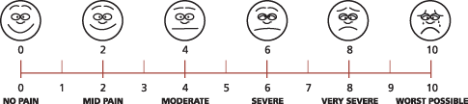

Pain Scale:

0 1 2 3 4 5 6 7 8 9 10

None Mild Moderate Severe

**OOOO Pins and Needles**

**XXXX Numbness**

**////////// Pain**

**= = = = Other**

Use the symbols listed above to describe the location and type of pain or unusual feelings you are having by drawing them on the pictures above

___________________________________________________________________________________________________

**Use the symbols listed below to describe the location and type of pain or unusual feelings you are having by drawing them on the pictures.**

**2)**